Cognizant Design Pattern and Principle
Exercise 1: Implementing singleton pattern
Output of the code
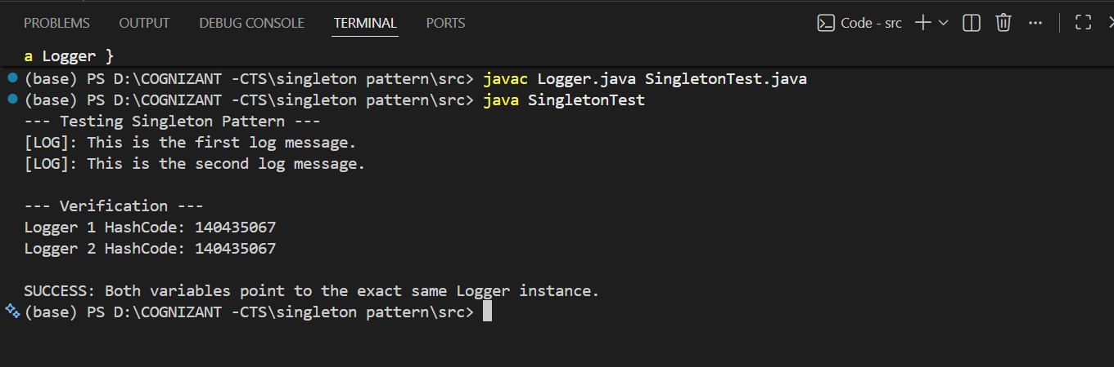

Screenshot of the code
